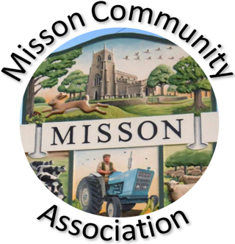
MISSON COMMUNITY ASSOCIATION

AGENDA

MEETING ON WEDNESDAY 19TH FEBRUARY 2025 AT 7.15 pm

- Apologies for absence

- Declarations of any new committee member interests outside MCA.

- Minutes of 15th January 2025.

- Non-agenda matters arising from minutes 15th January 2025

- Treasurer’s report

- Building maintenance

- Current Events and Bookings

Live and Local “Jack’s Ashes” Thursday 20th February
Race Night Friday 28th February
Misson Live – Sunday 4th May
Summer Garden Trail – dates to be agreed.
Party on the Green 2025 Saturday 26th July

- Proposed Events

Book Club
Nature walks
Gardening talks
Bassetlaw Spring Clean 12th April

- Working with other village groups

- Correspondence/Contact/Communication (Facebook, Posters, NL etc.)

- Any other business

Energy Audit
Hall inventory
Facebook security
First Aid training

- Date and time of next meeting – Wednesday 19th March at 7.15pm

