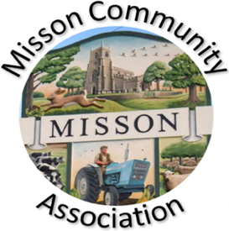
MISSON COMMUNITY ASSOCIATION

AGENDA

MEETING ON WEDNESDAY 16TH SEPTEMBER 2026 AT 7.15 PM

- Apologies for absence

- Declarations of any new committee member interests outside MCA.

- Minutes of 19th August 2026.

- Non-agenda matters arising from minutes 19th August 2026.

- Treasurer’s report

- Building maintenance

Replacement taps in toilets
Fire extinguisher testing

- Current Events and Bookings

Tuesday 15th September 19.30 – Vermuyden 400 talk
Sunday 27th September – Misson Beat Surgery 11.00
Friday 9th October - Appraisal Tim Marriott
Friday 23rd October – Church Harvest Quiz and Supper
Saturday 31st October – Church Table Top Sale
Saturday 31st October – Children’s Halloween Party
Friday 13th November – Marcella’s Minute to Minute
Sunday 22nd November – Christmas Fayre
Wednesday 9th December – Over 65s Christmas Lunch, White Horse

- Proposed Events

Notts Rural Watch initiative. Proposed explanatory talk to the village. On hold – date tbc.
Spooky Stories - Autumn

- Working with other village groups

- Correspondence/Contact/Communication (Facebook, Posters, NL etc.)

- Any other business

Over 65s Christmas Lunch
MCA Constitution

- Date and time of next meeting – Wednesday 21st October at 7.15pm

