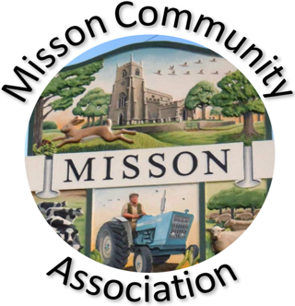
MISSON COMMUNITY ASSOCIATION

AGENDA

MEETING ON WEDNESDAY 16TH APRIL 2025 AT 7.15 pm

- Apologies for absence

- Declarations of any new committee member interests outside MCA.

- Minutes of 19th February 2025.

- Non-agenda matters arising from minutes 19th February 2025

- Treasurer’s report

- Building maintenance

- Current Events and Bookings

Misson Live – Sunday 4th May
Live & Local “Yours Sincerely” Thursday 8th May
VE 80 Day Thursday 8th May
Early morning Bird Walk Saturday 10th May
Wildflower Talk – Tuesday 20th May
Summer Garden Trail – 28th-29th June
Party on the Green 2025 Saturday 26th July

- Proposed Events

Nature walks
Gardening talks
Bassetlaw Spring Clean 12th April

- Working with other village groups

- Correspondence/Contact/Communication (Facebook, Posters, NL etc.)

- Any other business

Facebook security
First Aid training
Increase in cleaning rate

- Date and time of next meeting – Wednesday 21st May at 7.15pm

