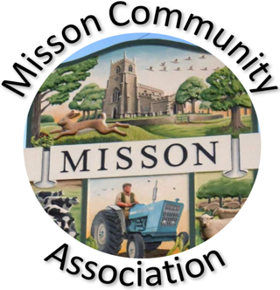
MISSON COMMUNITY ASSOCIATION

AGENDA for meeting on 19th January 2022

- Apologies for absence

- Minutes of meeting 17th November 2021

3. Non-agenda matters arising from minutes of 17th November 2021

- Treasurer’s report

- Christmas events

Christmas fayre
Over 65’s lunch. Thanks to NCC and White Horse

- Building maintenance and improvements

Update of meeting with MPC and actions to date

- Storage

Safe storage of combustibles
General streamlining

- Correspondence

- Communication

- Future events

Pizza evening
Madame Crepe pancakes
Queen’s Jubilee 2022
Fund raising events

- Any other business

- Date and time of next meeting – Wednesday 16th February 2022 at 7.00 pm.

