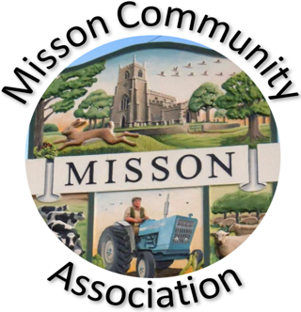
MISSON COMMUNITY ASSOCIATION

AGENDA

Meeting on THURSDAY 15TH NOVEMBER 2023 at 7.15 pm

- Apologies for absence

- Declarations of any Committee member interests outside MCA.

- Minutes of meeting 18th October 2023

- Non-agenda matters arising from minutes of 18th October 2023

- Treasurer’s report and Outline Budget for 2024

- Community centre lease and management

- Building maintenance and improvements

Oil filled radiators to boost hall temperature
Hall acoustics – going forward

- Bookings and Future Events

St. John the Baptist Community Café on Tour
Live and Local
Spring Village Clear Up or more regular clear ups
Christmas Fayre - Sunday 26th November
Christmas Lunch for over 65s - Wednesday 13th December
Race Night - Friday 1st March 2024

- Correspondence/Contact/Communication (Facebook, Posters, NL etc.)

- Any other business

- Date and time of next meeting – Wednesday 17th January 2024 at 7.15 pm.

