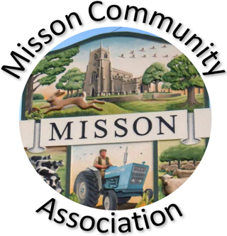
MISSON COMMUNITY ASSOCIATION

AGENDA

MEETING ON WEDNESDAY 18TH JUNE 2025 AT 7.15 pm

- Apologies for absence

- Declarations of any new committee member interests outside MCA.

- Minutes of 21st May 2025.

- Non-agenda matters arising from minutes 21st May 2025

- Treasurer’s report

- Building maintenance

- Current Events and Bookings

Doncaster Art Club weekend 21st and 22nd June
First Aid for Dogs 29th June
Summer Garden Trail – 28th-29th June
Summer School
Party on the Green 2025 Saturday 26th July

- Proposed Events

- Working with other village groups

- Correspondence/Contact/Communication (Facebook, Posters, NL etc.)

- Any other business

Animals in the Hall
Facebook security
First Aid training

- Date and time of next meeting – Wednesday 16th July at 7.15pm

