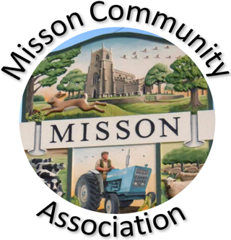
MISSON COMMUNITY ASSOCIATION

AGENDA

MEETING ON WEDNESDAY 19TH NOVEMBER 2025 AT 7.15 pm

- Apologies for absence

- Declarations of any new committee member interests outside MCA.

- Minutes of 15th October 2025.

- Non-agenda matters arising from minutes 15th October 2025.

- Treasurer’s report

- Building maintenance

- Current Events and Bookings

Village Clean Up 22nd November
Christmas Fayre Sunday 23rd November
Music evening (Viv Shilling) 29th November
Over 65s Christmas Lunch at THE ANGEL Thursday 11th December
Christmas Trail 15th December
Christmas events
Race Night Friday 27th February 2026

- Proposed Events

- Working with other village groups

- Correspondence/Contact/Communication (Facebook, Posters, NL etc.)

- Any other business

Review of MCA Constitution
Back garden area – bulbs and planters
Storing and loaning wildlife books

- Date and time of next meeting – Wednesday 19th November at 7.15pm

