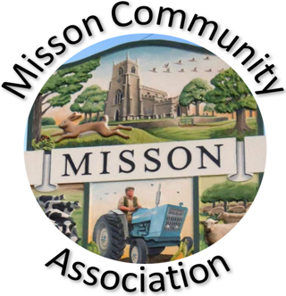
MISSON COMMUNITY ASSOCIATION

AGENDA

MEETING ON WEDNESDAY 20TH NOVEMBER 2024 AT 7.15 pm

- Apologies for absence

- Declarations of any new committee member interests outside MCA.

- Minutes of 16th October 2024.

- Non-agenda matters arising from minutes.

- Treasurer’s report

- Building maintenance

Lights and socket

- Current Events and Bookings

Live and Local Arrangements
Christmas Fayre. Entry from 11.00 on Sunday 24th November. Doors open 1.00-3.30.
Over 65’s lunch. Thursday 12th December The Angel. Arrive 12.00 to start eating 12.30.
Party on the Green 2025 Saturday 19th July 2025

- Correspondence/Contact/Communication (Facebook, Posters, NL etc.)

Facebook security

- Energy Audit

- Hall inventory – January 2025

- Any other business

Village Show
Defib battery
First responder
First Aid training
Nature walks - 2025

- Date and time of next meeting – Wednesday 15th January 2025 at 7.15pm

